**DATA SCINECE IMPLEMENTATION**

SUBMITTED BY

**SHUBHAM KALE**

**2022-2023**

**HSNC UNIVERSITY**

MASTERS OF SCIENCE IN INFORMATION TECHNOLOGY KISHINCHAND CHELLARA COLLEGE

D.W.ROAD, CHURCHGATE, MUMBAI – 400 020.

MS-FIT-210

DATA SCIENCE IMPLEMENTATION



# Churchgate, Mumbai - 400 020.

**DEPARTMENT OF INFORMATION TECHNOLOGY M.Sc. PART- I**

**CERTIFICATE**

# This is to certify that the practical done at **K.C. College** by **Mr. Shubham Kale** (Seat No: **KFMSCIT015**) in partial fulfillment for M.SC. (I.T.) Degree Examination has been found satisfactory. This Practical journal had not been submitted for any other examination and does not form part of any other course undergone by the candidate.

|  |  |  |
| --- | --- | --- |
| **Signature** | **Signature** | **Signature** |
| **Lecturer-in-charge** | **External Examiner** | **Course Coordinator** |
| **Guided by** | **Examined by** | **Certified by** |

**College Stamp**

**INDEX**

|  |  |  |  |
| --- | --- | --- | --- |
| **SR.**  **NO.** | **PRACTICAL NAME** | **REMARK** | **SIGN.** |
| 01 | Convert from XML to Horus |  |  |
| 02 | Convert from JSON to Horus |  |  |
| 03 | Convert from SQL to Horus |  |  |
| 04 | Convert all formats to Horus |  |  |
| 05 | Convert from Image to Horus |  |  |
| 06 | Convert from Video to Horus |  |  |
| 07 | Convert from Audio to Horus |  |  |
| 08 | Generating Reports in Power BI |  |  |
| 09 | Data visualization & transform in Power BI |  |  |

**PRACTICAL 01: CONVERT FROM XML TO HORUS**

**Code:**

import pandas as pd  
import xml.etree.ElementTree as ET  
  
print("SHUBHAM KALE,15")  
cols=["name","phone","gender"]  
rows=[]  
  
*#Parse XML file*tree=ET.parse('Company.xml')  
root=tree.getroot()  
  
for elem in root:  
 name = elem.find('name').text  
  
 phone = elem.find('phone').text  
  
 gender = elem.find('gender').text  
  
rows.append({"name":name,"phone":phone,"gender":gender})  
  
df = pd.DataFrame(rows,columns=cols)  
df.to_csv('employee.csv',index=False)  
  
print("XML to CSV format")  
emp = pd.read_csv('employee.csv')  
print(emp)  
print('Done')

**Output:**

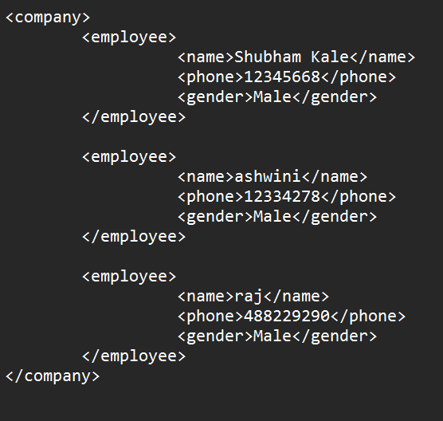 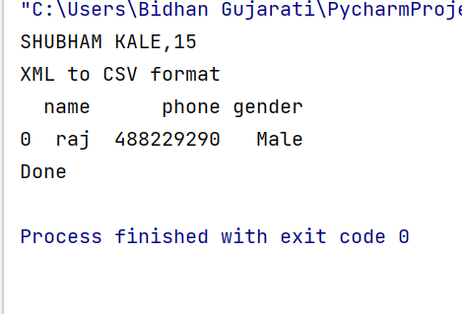

**PRACTICAL 02: CONVERT FROM JSON TO HORUS**

**Code:**

import pandas as pd  
import json  
import csv  
  
print("SHUBHAM KALE, 15")  
  
with open('emp_details.json') as json_file:  
 data = json.load(json_file)  
  
employee_data = data['emp_details']  
  
data_file = open('data_file.csv', 'w')  
  
csv_writer = csv.writer(data_file)  
count = 0  
  
for emp in employee_data:  
 if count == 0:  
 *# Writing headers of CSV file* header = emp.keys()  
 csv_writer.writerow(header)  
 count += 1  
  
 *# Writing data of CSV file* csv_writer.writerow(emp.values())  
  
data_file.close()  
print("JSON to csv format")  
emp=pd.read_csv('data_file.csv')  
print("\n Employee Details")  
print(emp)

**Output:**

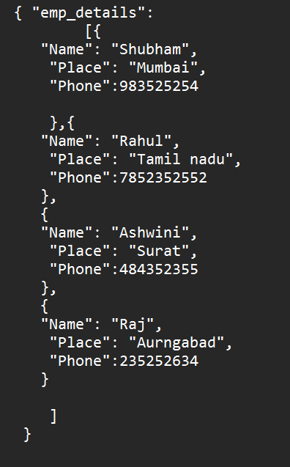

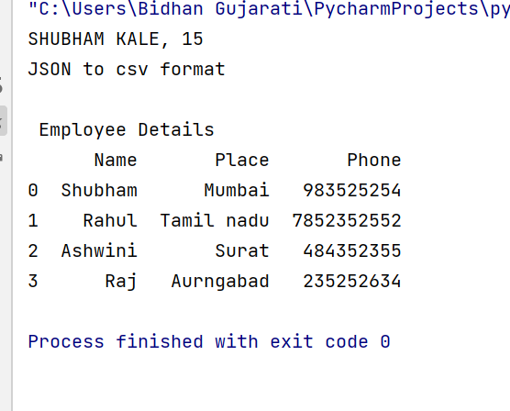

**PRACTICAL 03: CONVERT FROM SQL TO HORUS**

## Code:

## Step :- 1 Convert csv to sql

import pandas as pd  
import sqlite3 as sq  
print('Shubham Kale,15')  
sInputFileName = 'studs.csv'  
InputData = pd.read_csv(sInputFileName)  
print(InputData)  
ProcessData = InputData  
OutputData = ProcessData  
SOutputFileName = 'utility.db'  
sOutputTable = 'Employee'  
conn = sq.connect(SOutputFileName)  
OutputData.to_sql(sOutputTable, conn, if_exists='replace')  
print('Done')

## Output:

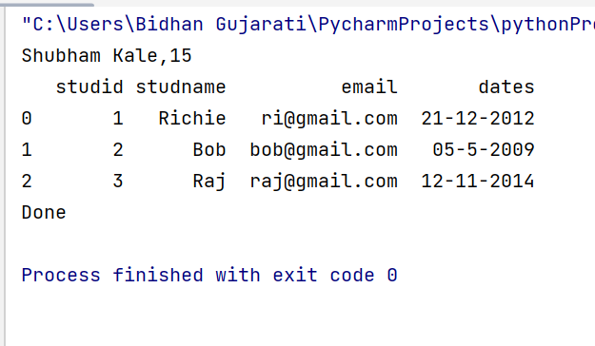

## Step :- 2 Convert sql to HORUS

import pandas as pd  
import sqlite3 as sq  
print("SHUBHAM KALE,15")  
sInputFileName='utility.db'  
sInputTable='Employee'  
*#creating connection*conn=sq.connect(sInputFileName)  
sSql='select * from ' + sInputTable + ';'  
InputData=pd.read_sql_query(sSql,conn)  
print(InputData)  
ProcessData=InputData  
*#Remove the Column ProcessData.drop('dates',axis=1,inplace=True)*print("Process data value=============================")  
print(InputData)  
*#Rename the Column*ProcessData.rename(columns={'studname':'Name'},inplace=True)  
ProcessData.rename(columns={'email':'EmailId'},inplace=True)  
print(ProcessData)  
OutputData=ProcessData  
OutputData.to_csv('employee1.csv')  
print('Done')

## Output:

## 

**PRACTICAL 04: CONVERT ALL FORMATS TO HORUS**

**Code:**

import pandas as pd  
import xml.etree.ElementTree as ET  
print('Shubham kale, 15')  
cols = ["name", "phone", "email"]  
rows = []  
tree = ET.parse('Company.xml')  
root = tree.getroot()  
for elem in root:  
 name = elem.find('name').text  
 phone = elem.find('phone').text  
rows.append({"name": name, "phone": phone})  
df = pd.DataFrame(rows, columns=cols)  
df.to_csv('employee.csv', index= False)  
df.to_csv('AllinOne.csv', mode='a', index=False, header=True)  
print("XML to CSV format")  
emp = pd.read_csv('employee.csv')  
print(emp)  
print('Done')  
sInputFileName = 'studs.csv'  
InputData = pd.read_csv(sInputFileName)  
print("CSV to CSV format")  
print("============Input Data Value============")  
print(InputData)  
ProcessData = InputData  
OutputData = ProcessData  
OutputData.to_csv('AllinOne.csv', mode='a', index=False, header=True)  
print('Done')

**Output:**

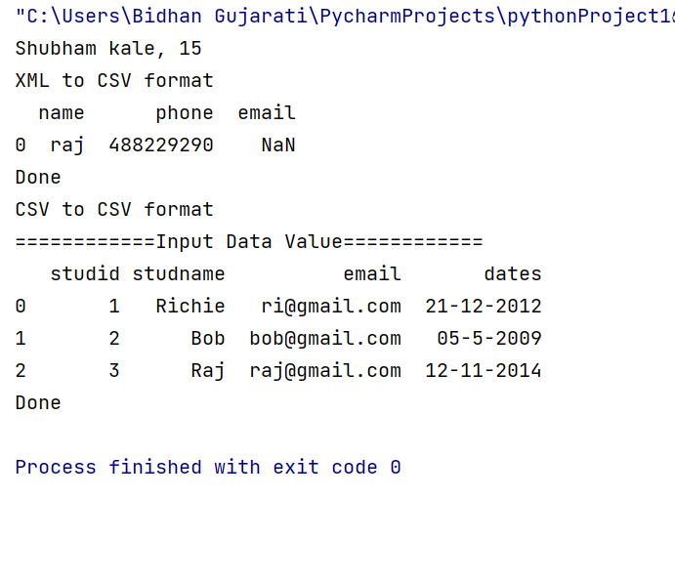

**PRACTICAL 05: CONVERT FROM IMAGE TO HORUS**

**Code**

#Convert Image to CSV File

from PIL import Image

import numpy as np

import sys

import os

import csv

print("Shubham KALE,15")

#Path to image

image_path='C:/Users/HP/Downloads/img (2).jpg'

#image_path='./temp/429.jpg'

output_file='output_image.csv'

print('processing image from'+image_path)

img_file=Image.open(image_path)

#get original image parameter

width,height=img_file.size

format=img_file.format

mode=img_file.mode

#Make image Grayscale

img_grey=img_file.convert('L')

#Save GreyScale value

value=np.asarray(img_grey.getdata(),dtype=int).reshape((img_grey.size[1],img_grey.size[0]))

value=value.flatten()

print(value)

with open(output_file,'a') as f:

writer = csv.writer(f)

writer.writerow(value)

print('saved file as' + output_file)

**Output:**

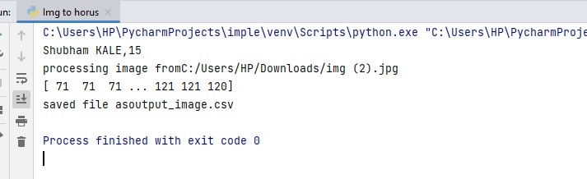

**PRACTICAL 6: CONVERT FROM VIDEO TO HORUS**

Code :

import cv2

import os

print("SHUBHAM KALE,15")

#Read the video from Specified path

cam=cv2.VideoCapture('video1.mp4')

try:

if not os.path.exists('temp'):

os.mkdir('temp')

except OSError:

print("Error: Creating Directory")

#frame

currentframe=0

while(True):

ret,frame=cam.read()

if ret:

name='./temp/'+str(currentframe)+'.jpg'

print('Creating Frame')

cv2.imwrite(name,frame)

currentframe+=1

else:

break

cam.release()

cv2.destroyAllWindows()

Output:

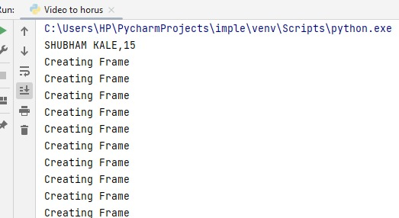

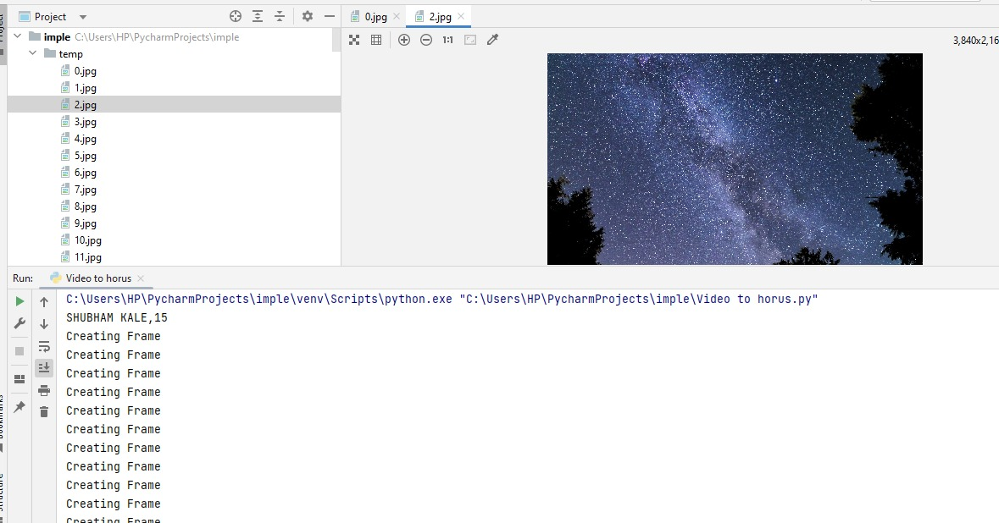

**PRACTICAL 07: CONVERT FROM AUDIO TO HORUS**

**Code:**

from scipy.io import wavfile

import pandas as pd

import matplotlib.pyplot as plt

import numpy as np

def show_info(aname, a,r):

print ('----------------')

print ("Audio:", aname)

print ('----------------')

print ("Rate:", r)

print ('----------------')

print ("shape:", a.shape)

print ("dtype:", a.dtype)

print ("min, max:", a.min(), a.max())

print ('----------------')

plot_info(aname, a,r)

def plot_info(aname, a,r):

sTitle= 'Signal Wave - '+ aname + ' at ' + str(r) + 'hz'

plt.title(sTitle)

sLegend=[]

for c in range(a.shape[1]):

sLabel = 'Ch' + str(c+1)

sLegend=sLegend+[str(c+1)]

plt.plot(a[:,c], label=sLabel)

plt.legend(sLegend)

plt.show()

sInputFileName='abcd1.wav'

print('=====================================================')

print('Processing : ', sInputFileName)

print('=====================================================')

InputRate, InputData = wavfile.read(sInputFileName)

show_info("2 channel", InputData,InputRate)

ProcessData=pd.DataFrame(InputData)

sColumns= ['Ch1','Ch2']

ProcessData.columns=sColumns

OutputData=ProcessData

sOutputFileName='HORUS-Audio-1ch.csv'

OutputData.to_csv(sOutputFileName, index = False)

print('=======================Excel file generated========================================')

Output:

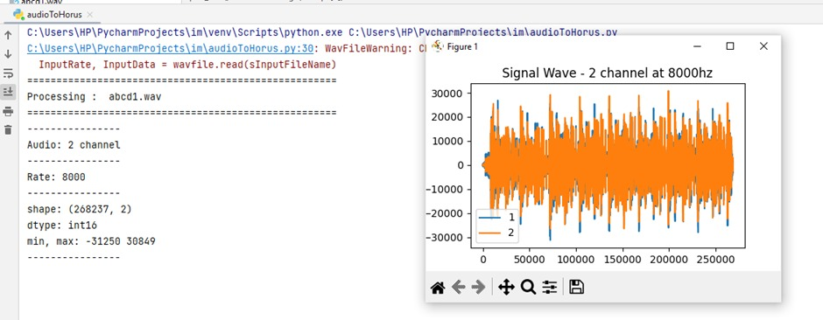

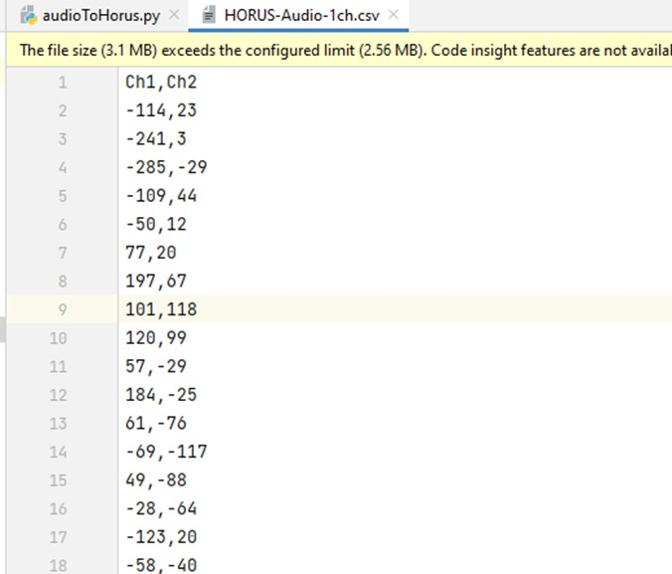

**PRACTICAL 08: GENERATING REPORTS IN POWER BI**

**Steps:**

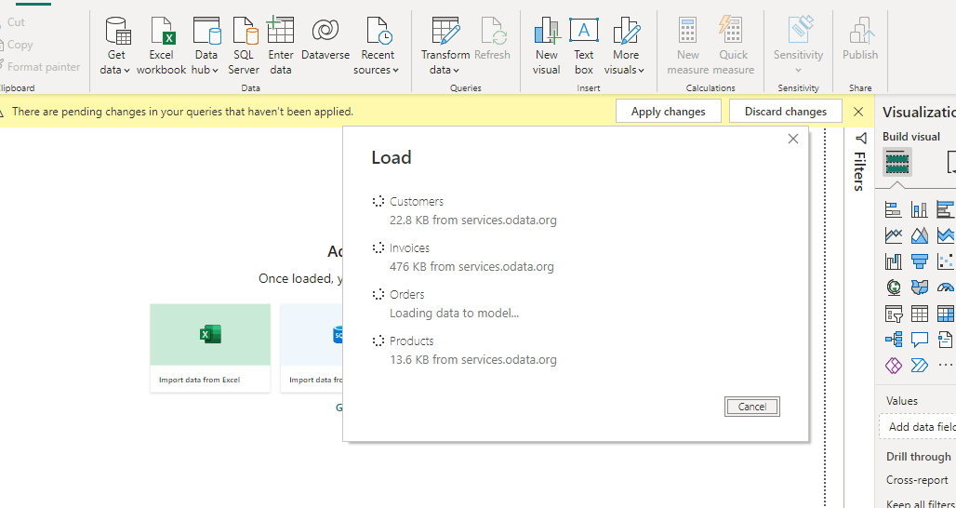

Click On Model view

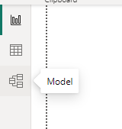

Click on arrow like button

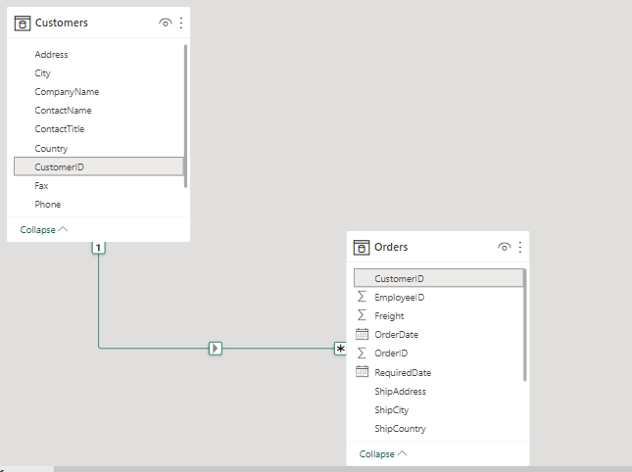

Right click and Select Properties

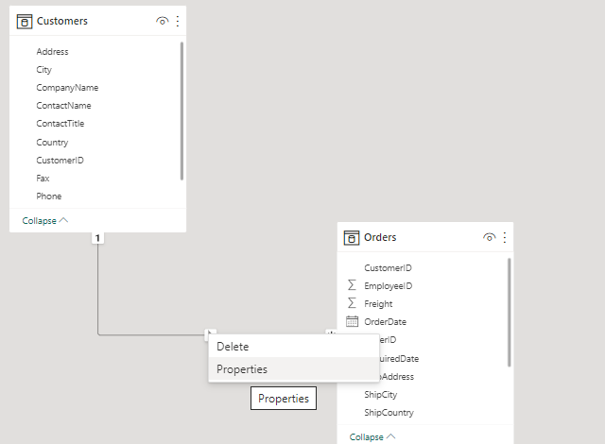

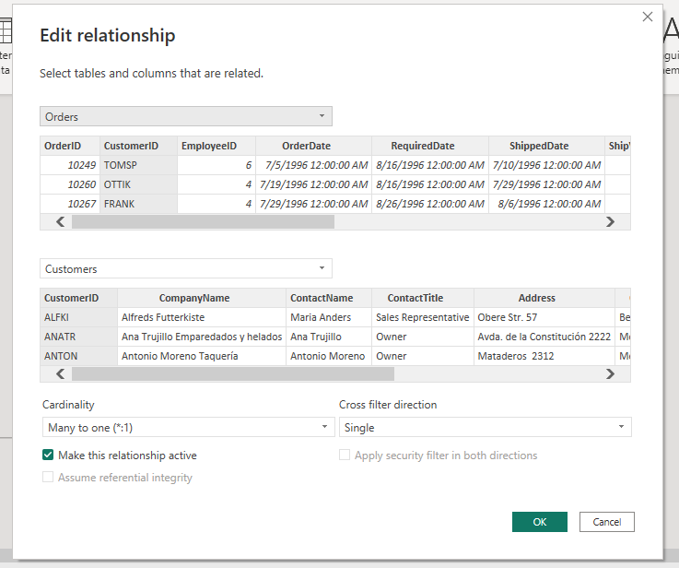

Click Okay

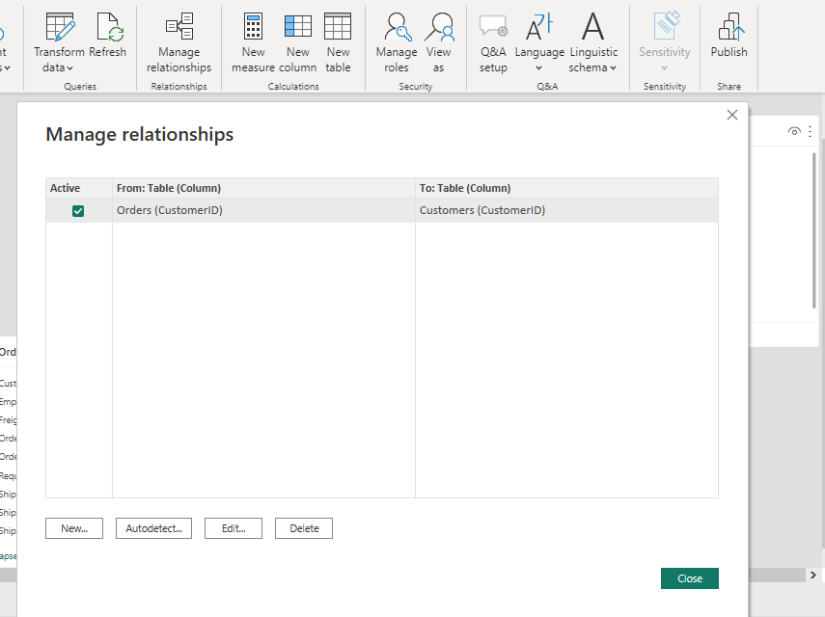

Select MAnage Relationship---> click on New

From dropdrow select First order and then invoice

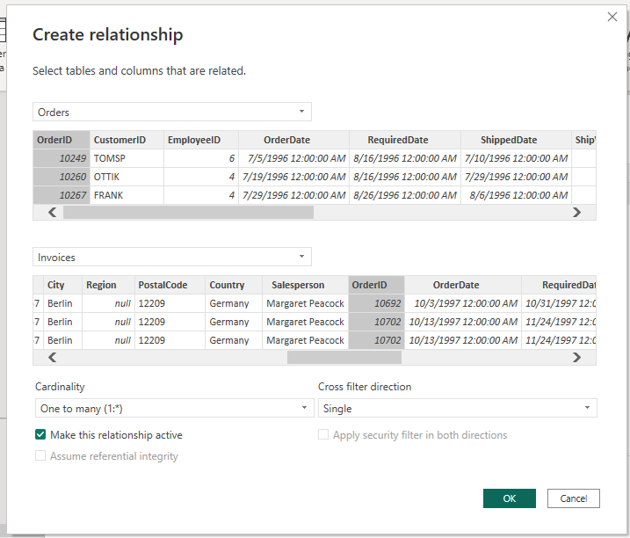

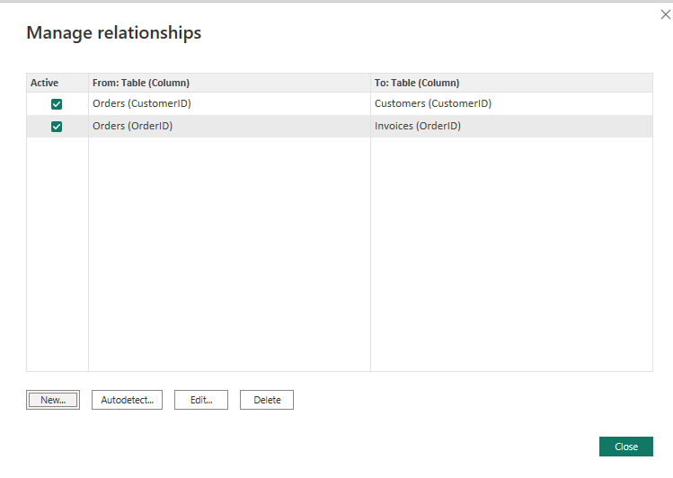

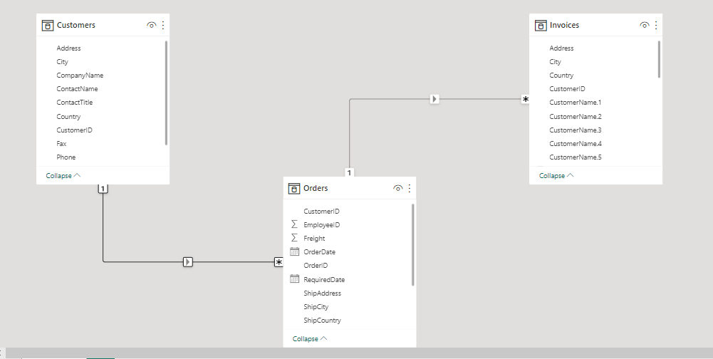

Go in Report View

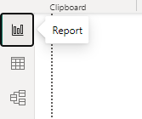

In visualization select linechart

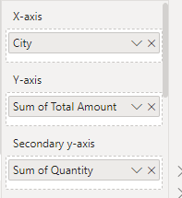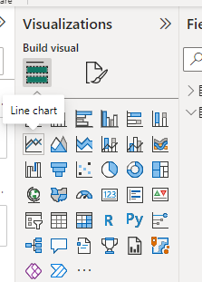 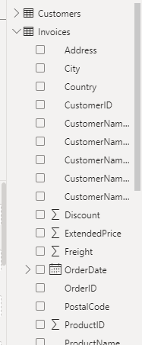

Use Invoice Table

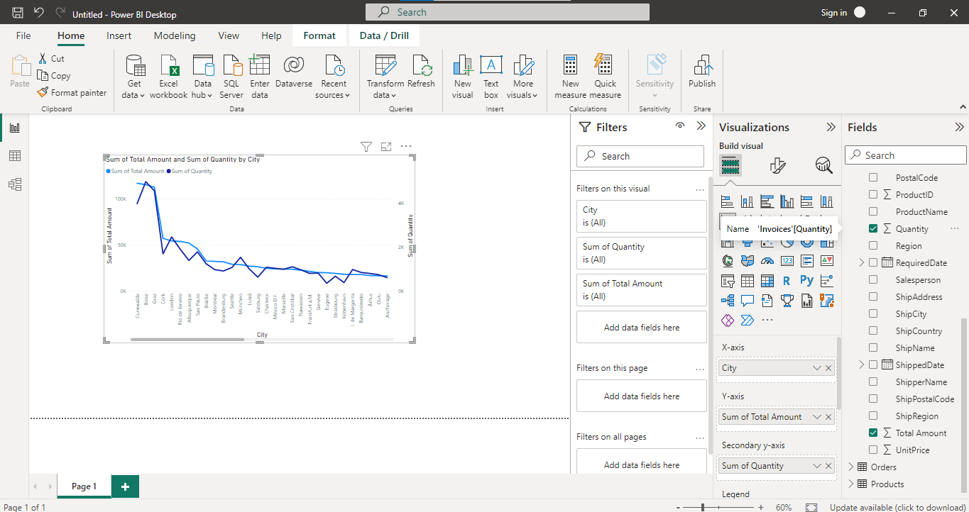

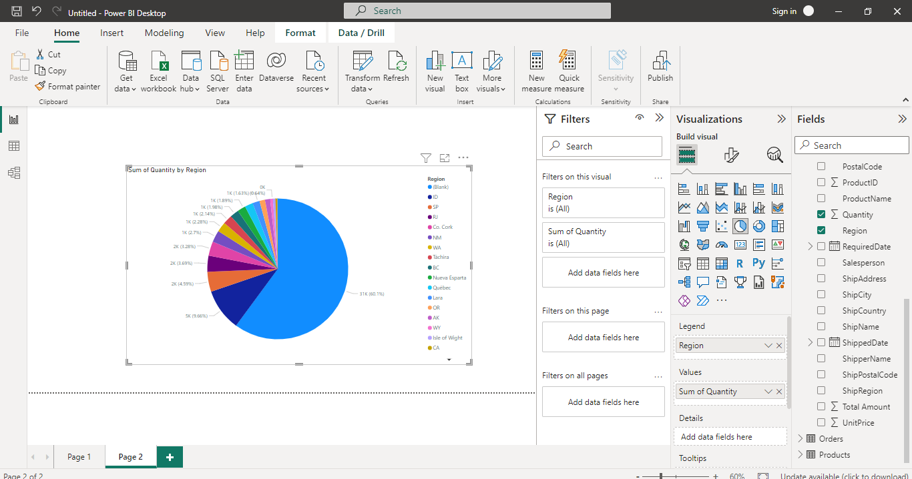

**PRACTICAL 09: DATA VISUALIZATION & TRANSFORM IN POWER BI**

**Steps:**

Select ->Getdata>OData feed

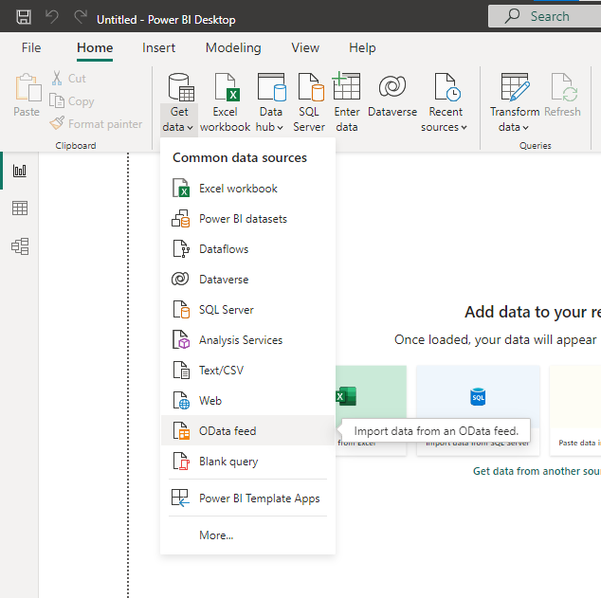

<http://services.odata.org/V3/Northwind/Northwind.svc/>

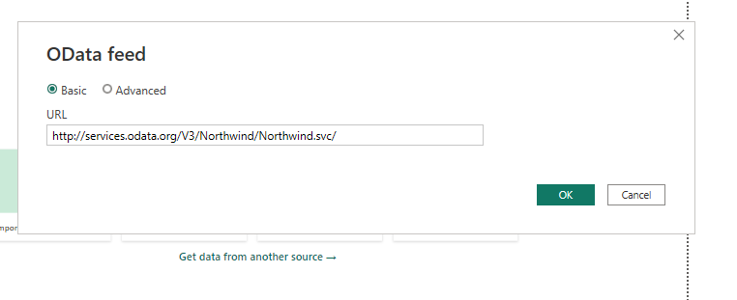

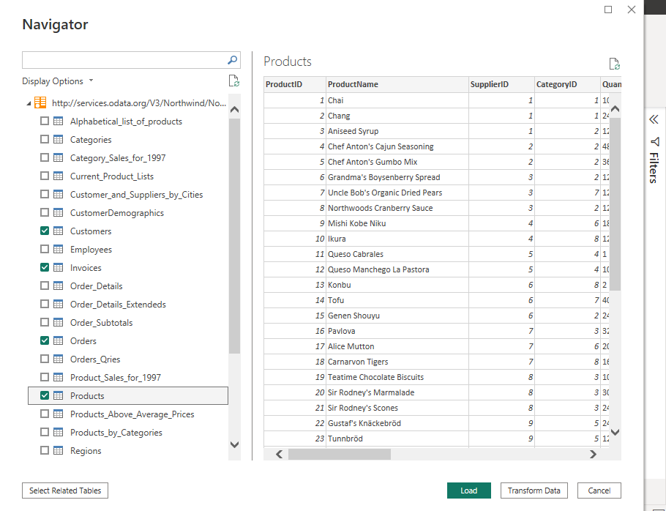

Select Transfrom Data

Select Invoices

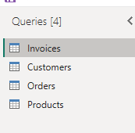

Select Unit Price

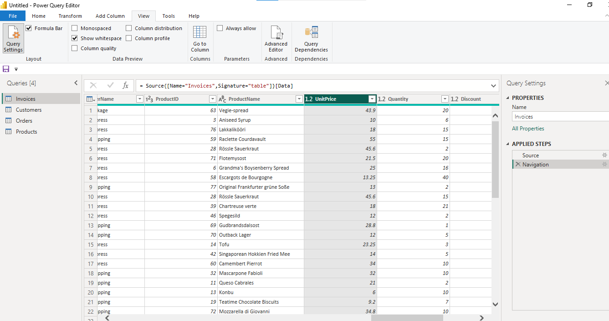

Select Whole Number

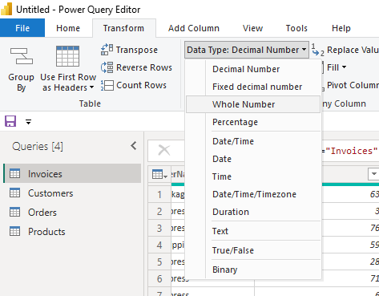

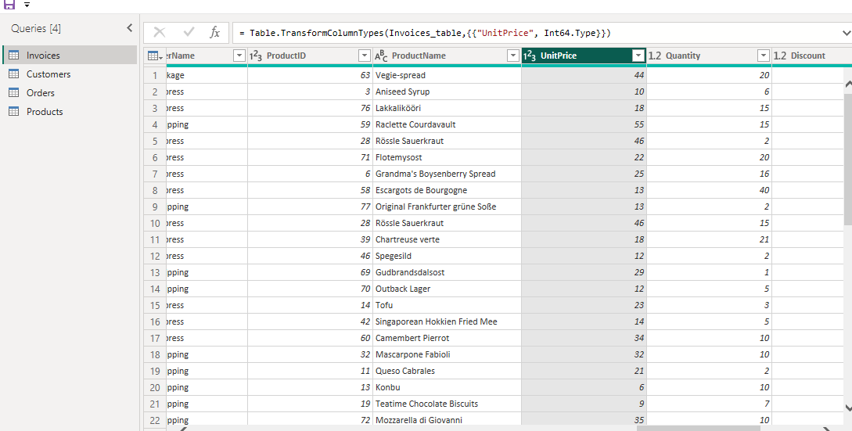

Now Select Cutomer Name

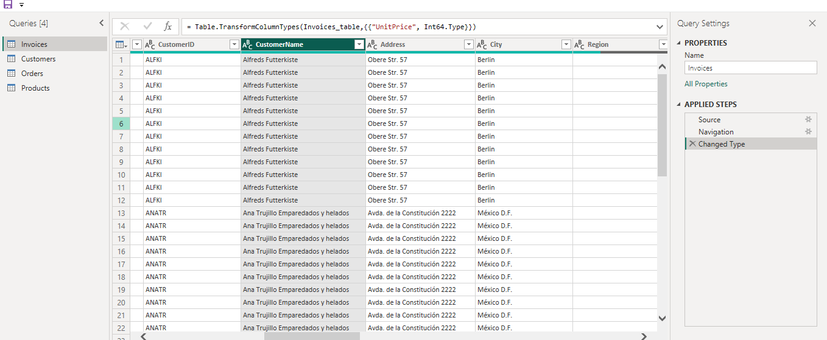

Select Delimeter

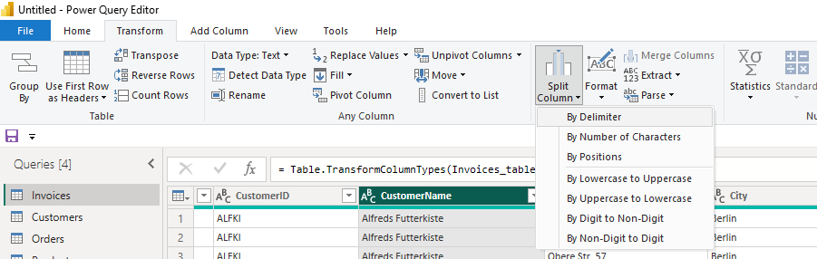

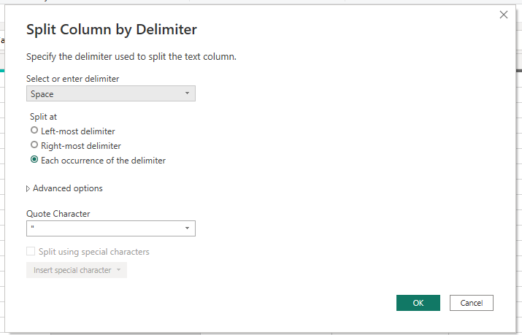

Click Okay :)

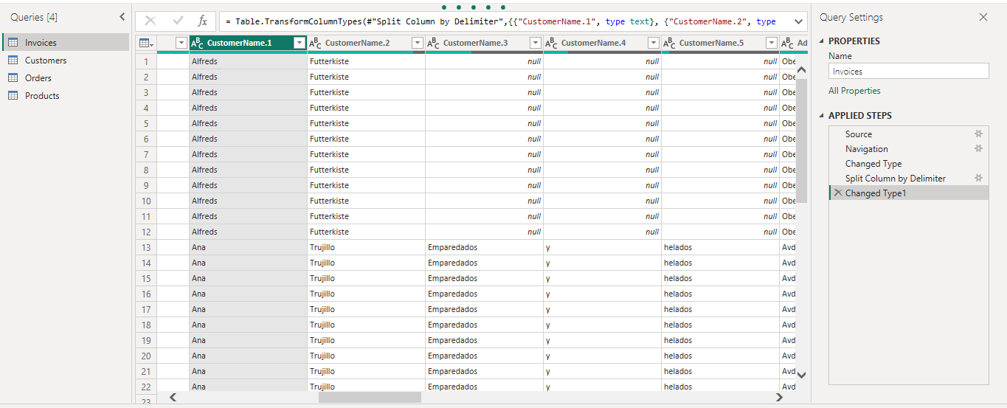

Go in add column>custom column

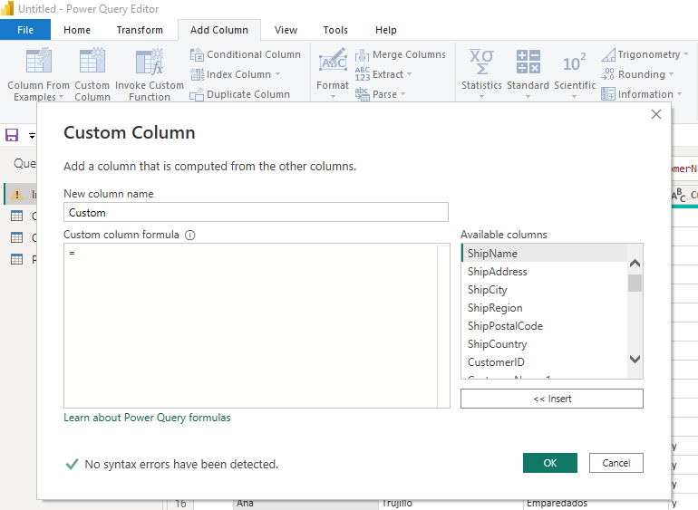

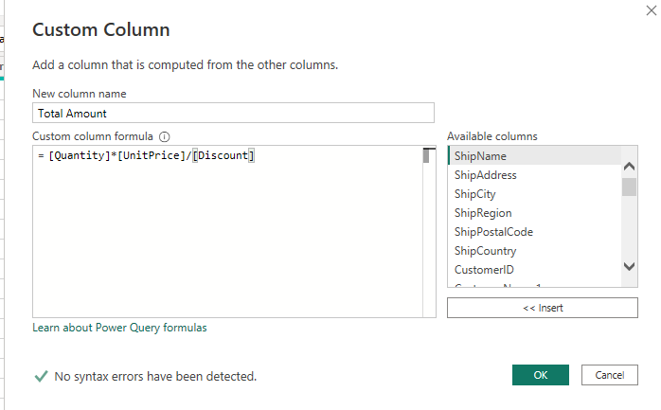

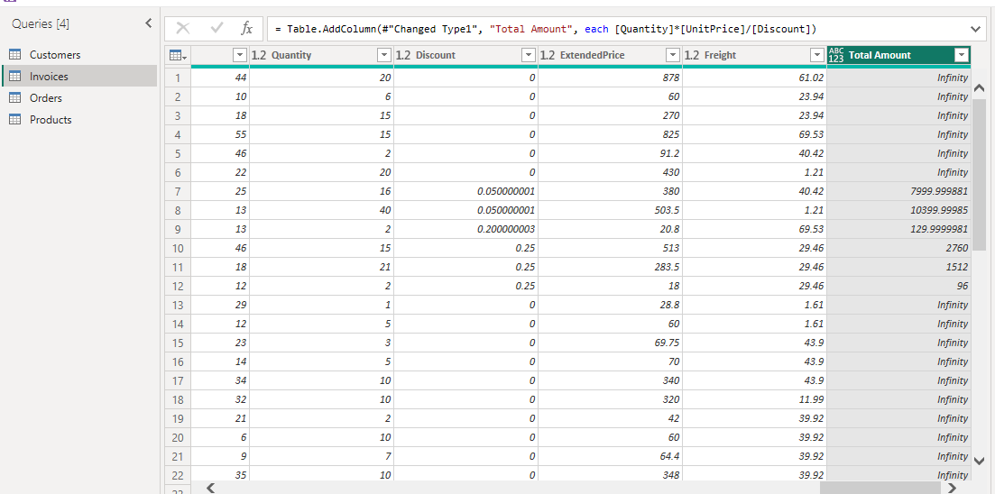

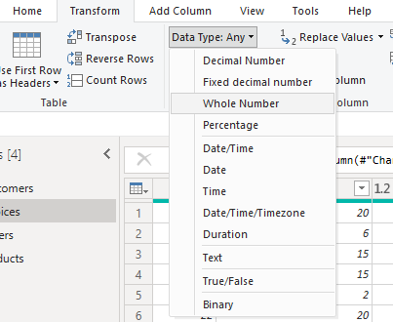

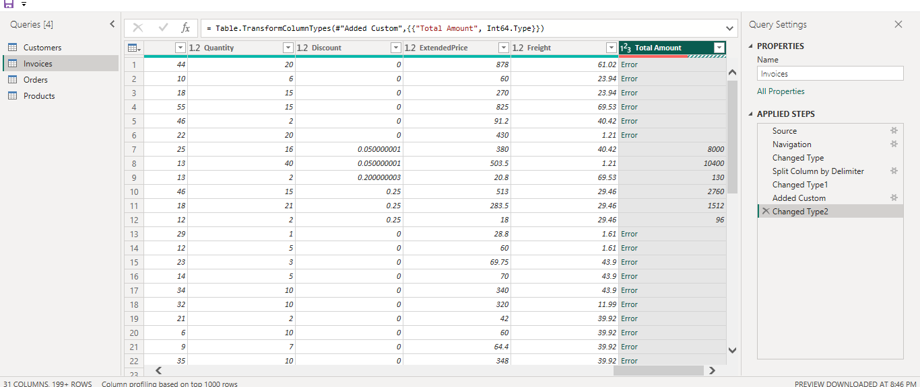

Click on Added Cutom sitting icon

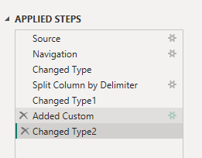

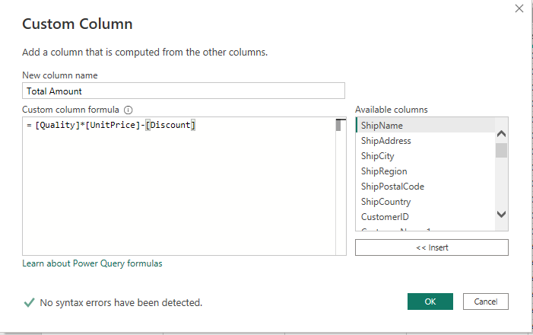

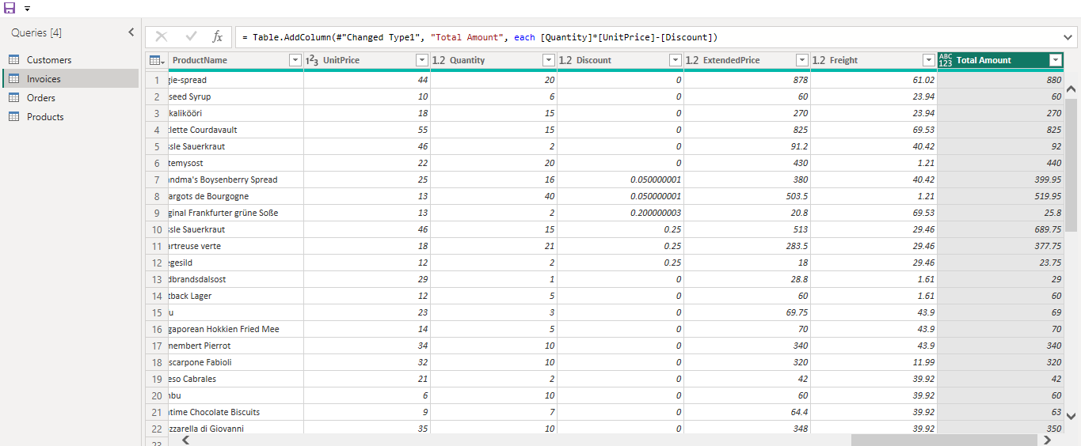

Go in home Tab> Close Apply

